Spartacus Educational Classroom Activity

Cardinal Thomas Wolsey
http://spartacus-educational.com/ExTEU23.htm

Thomas Wolsey was appointed dean of divinity in Magdalen College in 1501. Wolsey became associated with Richard Foxe, bishop of Winchester. Foxe recommended him to Henry VIII. As a result he became the king's almoner in November 1509. It is suggested that Wolsey "fascinated the young king, who shirked business, but admired brilliance, energy and wit."
George Cavendish claims that Wolsey soon gained the appreciation of the young monarch as he was the "most earnest and readiest in all the council to advance the king's only will and pleasure". According to Cavendish "Wolsey gained the favour of Henry VIII because the other counsellors tried to persuade Henry to preside at Council meetings, as his father had done, and Wolsey encouraged him to go hunting and enjoy himself while Wolsey governed the country for him. Cavendish added that whereas the other ministers advised Henry to do what they thought he ought to do, Wolsey found out what Henry wanted to do, and then advised him to do it."

Primary Sources

(Source 1) Thomas Wolsey by unknown artist (c. 1515)

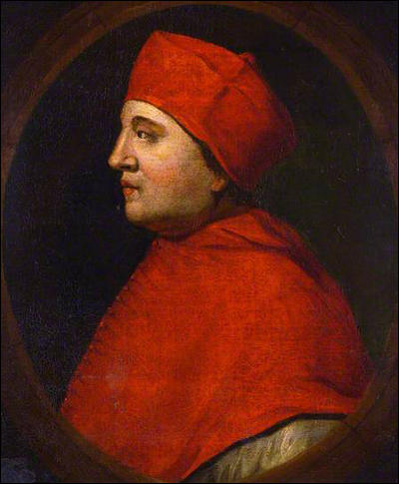

(Source 2) Raphael Holinshed, Chronicles (1587)
Thomas Wolsey was a poor man's son, of Ipswich... he reigned a long season, ruling all things within the realm.

(Source 3) Jasper Ridley, The Statesman and the Fanatic (1982)
Thomas Wolsey's father, Robert Wolsey... was a Yeoman farmer in the Suffolk village of Sternfield... Robert Wolsey married Joan Daundy, a member of the wealthy and influential Daundy family.... Robert Wolsey saw a chance of making money, and rising in the world, by opening a butcher's shop in Ipswich... in 1466.

(Source 4) Sybil M. Jack, Thomas Wolsey : Oxford Dictionary of National Biography (2004-2014)
Wolsey's father ran a tavern in the parish of St Mary at the Elms, Ipswich, from 1464 at the latest. It is most probable that Thomas was born there in October 1472... Robert traded as a butcher from about that time... Wolsey received his early education at Ipswich and proceeded to Oxford, where he graduated BA in 1486 from Magdalen, aged only fifteen... It is not known who paid for Thomas's education, but it may have been his mother's brother, Edmund Daundy, a successful merchant in St Lawrence parish, Ipswich, and burgess to the parliaments of 1511 and 1514.
(Source 5) Thomas Wolsey by unknown artist (c. 1520)

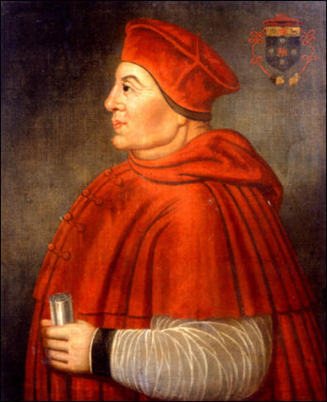

(Source 6) Peter Ackroyd, Tudors (2012)
Thomas Wolsey... seems almost at once to have impressed the young king with his stamina and masterly of detail... He had the gift of affability as well of industry, and was infinitely resourceful; he did what the king wanted, and did it quickly... He was thirty-eight years old, and a generation younger than the old bishops of the council. Here was a man whom the young king could take into his confidence, and upon whom he could rely. Wolsey rose at four in the morning, and could work for twelve hours at a stretch without intermission... When he had finished his labours he heard Mass and then ate a light supper before retiring.

(Source 7) John Edward Bowle, Henry VIII (1964)
As almoner and member of the Council (1509), he fascinated the young king, who shirked business, but admired brilliance, energy and wit... He hunted and danced; he lived in fabulous splendor, a tireless politician and diplomat, in a blaze of ambition and pride... As Chancellor and Legate he was virtually to rule England for seventeen years.

(Source 8) Jasper Ridley, Henry VIII (1984) page 58
Soon after his accession, Henry VIII appointed him (Thomas Wolsey) to be his almoner, and the autumn of 1511 he was made a member of the King's Council. He was far more energetic than the other counsellors, and in no time he was dominating the Council. In contrast to Foxe and Ruthall (Henry's two senior ministers), Wolsey was a very fast worker; and he was always ready to take a short cut instead of proceeding through the proper channels if this would help expedite business, even if it meant breaking the regulations... These qualities appealed to Henry....
According to George Cavendish... Wolsey gained the favour of Henry VIII because the other counsellors tried to persuade Henry to preside at Council meetings, as his father had done, and Wolsey encouraged him to go hunting and enjoy himself while Wolsey governed the country for him. Cavendish added that whereas the other ministers advised Henry to do what they thought he ought to do, Wolsey found out what Henry wanted to do, and then advised him to do it...
Wolsey was just the minister that Henry required. He would carry out the duties of government very efficiently, and take the burden of state affairs off Henry's shoulders, while always informing Henry of what was happening and consulting with him, and always leaving the final decision to the King.

(Source 9) George Cavendish, The Life and Death of Cardinal Wolsey (c. 1558)
Cardinal Wolsey had a special gift of natural eloquence with a filed tongue to pronounce the same... He was therefore able... to persuade and allure all men to his purpose... The almoner ruled all them that before ruled him.

(Source 10) John Guy, Tudor England (1986)
When the older councillors, bred under Henry VII, complained that his son was too wedded to pleasure and suggested that he attend Council meetings more regularly, Wolsey, to Henry VIII's delight, counselled the exact opposite. George Cavendish claimed Wolsey openly offered to relieve Henry of the weight of public affairs; it seems unlikely but Wolsey got his way by whatever means. Wolsey... had no guiding political principles. He was flexible and opportunist; he thought in European terms and on the grand scale; and he was the consummate politician.... Wolsey interfered constantly in the affairs of the nobility, leading gentry, and citizens of London, and demanded the attendance of many of them at Court...
It scarcely be denied that Wolsey's buildings, chapels, art collections, and projected tomb, as well as the style and size of his household, marked conscious attempts to rival Henry. Foreign envoys described Wolsey as a "second king" almost all of the time, and not simply when he was playing the diplomatic game as Henry's surrogate abroad...
What he started, he rarely completed; he worked in fits and starts, stimulated by the scent of political advantage rather than sustained concern that policy should be seen through. As Lord Chancellor he sought better law enforcement, justice for the poor, and the Crown's re-endowment through regular taxation, but he met with mixed success; in particular he defied accepted constitutional wisdom by attempting to levy taxation without parliamentary consent.

(Source 11) Christopher Morris, The Tudors (1955) page 79
In England, moreover, papal power had come to mean the power of the Legate Thomas Wolsey who was hated not only by the nobles, the lawyers and the taxpayers, but by most of his own bishops. His wars and diplomacy, which had been expensive and inglorious, had almost all been either pro-papal or else intended to further his own designs on the papacy. Hatred of his power could and did slide easily into hatred for the Pope's. What the historian has to explain is not so much why there was a Reformation in England but why there was so little resistance to it; and in Wolsey it may well be thought that much of the explanation is to be found.

(Source 12) Roger Lockyer, Tudor and Stuart Britain (1985) page 34
Wolsey was a great prince of the Church in a tradition so alien to modern assumptions that it is difficult to comprehend him. Yet he was not without his virtues. He promoted education, and made his household a place where men of intelligence and ability learned how to serve the state. He was also tolerant, preferring to burn heretical books rather than the heretics themselves; and although he rose to power by royal favour he was not unworthy of it, for he had an enormous capacity for work, and he knew how to win men.

(Source 13) Eustace Chapuys, report to King Charles V (1st September, 1529)
The affairs of Cardinal Wolsey are getting worse every day... the cause of this misunderstanding between the King and the Cardinal can be no other than the utter failure of the measures taken in order to bring about the divorce.

(Source 14) Anna Whitelock, Mary Tudor: England's First Queen (2009) page 45
With the divorce case referred to Rome, there seemed little prospect of Henry securing a favourable judgement... It signalled Wolsey's fall from favour.... By October (1529), Wolsey had been charged with Praemunire - the illegal exercise of papal authority in England - in his role as legate. On the 22nd, having resigned the lord chancellorship to... Sir Thomas More, Wolsey acknowledged his offences and placed himself and his possessions in the King's hands.

(Source 15) Antonia Fraser, The Six Wives of Henry VIII (1992) page 165
According to George Cavendish (writing much later, but before the accession of Anne Boleyn's daughter), it was Anne herself who was responsible for striking the decisive blow, having never forgiven Wolsey for his high-handed removal of her eligible lover, Lord Percy. Certainly many contemporaries attributed the Cardinal's disgrace to the influence of "the Lady"...
In political terms, the Cardinal had more powerful enemies: Thomas 3rd Duke of Norfolk, Anne's uncle, and Henry's brother-in-law the Duke of Suffolk, although not in alliance with each other, were both hostile to the prelate...
The Cardinal's rise had been long and hard-earned, industry, patience and arduous service accompanying every step. His fall was swift. A series of brutal coups stripped him of his powers, beginning with the Attorney-General on 9 October who charged him with praemunire, that is, exercising his powers of papal legate in the King's realm, thus derogating the King's lawful authority. He was dismissed as Lord Chancellor and sentenced to imprisonment. His fortune was stripped from him and all his goods taken "into the King's hands", in the words of the French ambassador.

Questions for Students
Question 1: Study sources 2, 3 and 4. One of these sources provides inaccurate information about Thomas Wolsey. Explain why the author might have made this mistake.
Question 2: Historians have different views on why Thomas Wolsey became Henry VIII's most important advisor. Compare the different views of the historians who produced sources 6, 7, 8 and 9.
Question 3: Sources 8, 10 and 15 refer to the biography written by George Cavendish. Read about Cavendish and explain why historians rely heavily on the work. Discuss the advantages and disadvantages of using Cavendish's book as a source of information on Thomas Wolsey.
Question 4: Use the information in sources 10, 11 and 12 to describe the good and bad qualities of Thomas Wolsey.
Question 5: Give as many reasons as you can why Thomas Wolsey was removed from power in 1529.

