Spartacus Educational Classroom Activity

Did Anne Boleyn have six fingers on her right hand? A Study in Catholic Propaganda.
http://spartacus-educational.com/ExTEU19.htm
Henry VIII met Anne Boleyn for the first time in 1523. He seemed to find her very entertaining and was often seen dancing with her. Hilary Mantel has pointed out: "We don't know exactly when he fell for Anne Boleyn. Her sister Mary had already been his mistress. Perhaps Henry simply didn't have much imagination. The court's erotic life seems knotted, intertwined, almost incestuous; the same faces, the same limbs and organs in different combinations. The king did not have many affairs, or many that we know about. He recognised only one illegitimate child. He valued discretion, deniability. His mistresses, whoever they were, faded back into private life. But the pattern broke with Anne Boleyn."
For several years Henry had been planning to divorce Catherine of Aragon. Now he knew who he wanted to marry - Anne. At the age of thirty-six he fell deeply in love with a woman some sixteen years his junior. Henry wrote Anne a series of passionate love letters. In 1526 he told her: "Seeing I cannot be present in person with you, I send you the nearest thing to that possible, that is, my picture set in bracelets ... wishing myself in their place, when it shall please you." Soon afterwards he wrote during a hunting exhibition: "I send you this letter begging you to give me an account of the state you are in... I send you by this bearer a buck killed late last night by my hand, hoping, when you eat it, you will think of the hunter."
We only have a couple of descriptions of Anne's appearance that has survived from her lifetime. This included the ambassadors, Mario Savorgnano and Jean du Bellay. Other accounts are based on information from other people. For example, Nicholas Sander, was only about six years old when Anne died and his account is based on stories that he had heard. George Wyatt was the grandson of Thomas Wyatt, who was close to Anne. He was her first biographer, who compiled his work at the end of the sixteenth century from the reminiscences of his family and those who had known her, such as her former maid of honour, Anne Gainsford.
Only a couple of portraits of Anne Boleyn have survived. The most famous portrait of her is that in the National Portrait Gallery, a copy of a lost original, painted between 1533 and 1536 (source 1). Some portraits said to be of Anne are of doubtful authenticity and others were painted long after her death (source 6). There is also a sketch by Hans Holbein (source 10). As Alison Weir has pointed out: "The sitter wears an English gable hood of the 1530s, and has dark hair, large eyes, a long nose and full, sensual lips; her face is fuller than shown in authentic portraits, and her chin not so pointed... Yet is this Anne? Because the sitter is shown from a different angle, it is hard to tell."

Primary Sources

(Source 1) Anne Boleyn, copy of a portrait painted in about 1534
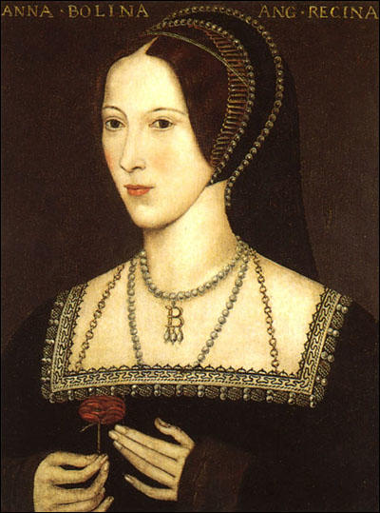

(Source 2) Mario Savorgnano, letter to the Signiory of Venice (October, 1532)
Mistress Anne is not one of the handsomest women in the world. She is of middling stature, swarthy complexion, long neck, wide mouth, bosom not much raised and in fact has nothing but the king's great appetite - and her eyes which are black and beautiful.

(Source 3) Nicholas Sander, Rise and Growth of Anglican Schism (1571) page 35
Anne Boleyn was rather tall of stature with black hair and an oval face of sallow complexion, as if troubled with jaundice. She had a projecting tooth under her upper lip, and on her right hand, six fingers. There was a large wen (tumour or wart) under her chin, and therefore to hide its ugliness, she wore a high dress covering her throat. She was handsome to look at... She was the model and the mirror of those who were at court, for she was always well dressed, and every day made some change in the fashion of her garments.

(Source 4) George Wyatt, wrote this account in the 1590s and was published in The Papers of George Wyatt (1968)
There was found, indeed, upon the side of her nail, upon one of her fingers, some little show of a nail, which yet was so small... albeit in beauty she was to many inferior, but for behaviour, manners, attire and tongue she excelled them all... she was indeed a very wilful woman... but yet that and other things cost her after dear.

(Source 5) Elizabeth Jenkins, Elizabeth the Great (1958)
Thin, black-eyes, excitable, tart and witty, Anne Boleyn made gentleness and amiability appear insipid. The French Ambassador Du Bellay said that the King's infatuation for her was such, that only God could abate his madness.
(Source 6) Anne Boleyn by Frans Pourbus (c. 1600)
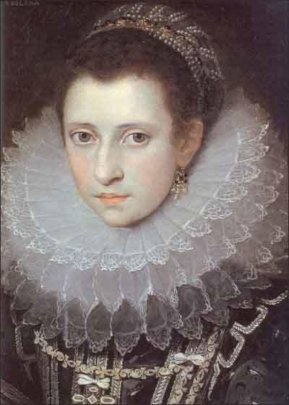

(Source 7) Alison Plowden, Tudor Women (2002)
It's never been easy to understand just what Henry saw in Anne Boleyn, or to define the secret of her undoubted fascination - probably it lay in that mysterious quality of sexual magnetism which defies an exact definition and has very little to do with physical beauty. Certainly Anne was not beautiful in any obvious sense. A brunette with a heavy mane of glossy black hair, a sallow skin and a rather flat-chested figure, her best feature seems to have been her large dark eyes which, according to one observer, "invited to conversation". But she knew how to make the best of herself. She dressed well and had become a leader of fashion at Court. She was lively, sophisticated and accomplished - a charming and witty companion, well versed in the arts of pleasing. She was also intelligent and courageous, aware of her own potential and restlessly seeking fulfilment in a world which offered few opportunities to ambitious, energetic and dissatisfied young women. Less attractive traits were her vindictive, sometimes vicious temper, her bitter tongue and her long memory for a grudge.

(Source 8) Retha M. Warnicke, The Rise and Fall of Anne Boleyn (1989)
The most complete extant description of Anne's appearance that has survived from her lifetime is in a hostile report of a Venetian ambassador, who described her when she was on a visit to Calais in 1532. Sympathetic to Catherine of Aragon, he said disparagingly about the king's love: "Madame Anne is not one of the handsomest women in the world; she is of middling stature, swarthy complexion, long neck, wide mouth, bosom not much raised, and in fact has nothing but the English king's great appetite and her eyes, which are black and beautiful."
In contrast, Nicholas Sander, who probably never saw Anne, claimed in his Latin history, which was published almost fifty years after her death, that she was very tall and physically disfigured. An enemy of her daughter, Queen Elizabeth, Sander attempted to ridicule the English Reformation by clothing Anne with the outer appearance that he thought best reflected her inner nature, as he perceived it. Believing that by her enchanting and sensuous ways she had manipulated a king besotted with passion for her into destroying both his marriage and the English Church, Sander gave her the invented monstrous features of a witch...
Some biographers have tried to reconcile the scurrilous remarks of Sander, the first writer to portray Anne publicly as deformed... Had there been even a hint of a deformity in Anne's appearance, the Venetian, as well as the Imperial ambassadors, some of whom knew her father quite well because of his diplomatic experience, would have eagerly revealed this intriguing fact to their respective governments.

(Source 9) Alison Weir, The Six Wives of Henry VIII (2007)
Pierre de Bourdeille Brantôme remembered Anne Boleyn in his later years as "the fairest and most bewitching of all the lovely dames of the French court". According to Lancelot de Carles, her most attractive feature was "her eyes, which she well knew how to use. In truth, such was their power that many a man paid his allegiance." She used her eyes, he tells us, to invite conversation, and to convey the promise of hidden passion. It was a trick that enslaved several men...
Anne's charm lay not so much in her physical appearance as in her vivacious personality, her gracefulness, her quick wit and other accomplishments. She was petite in stature, and had an appealing fragility about her. Her eyes were black and her hair dark brown and of great length; often, she would wear it interlaced with jewels, loose down her back. But she was not pretty, nor did her looks conform to the fashionable ideals of her time. She had small breasts when it was fashionable to have a voluptuous figure, and in a period when pale complexions were much admired, she was sallow, even swarthy, with small moles on her body. George Wyatt says she had a large Adam's apple, like a man's... Wyatt, grandson of the poet Thomas Wyatt and Anne's first biographer, who compiled his work at the end of the sixteenth century from the reminiscences of his family and those who had known her, such as her former maid of honour, Anne Gainsford.
Anne did have a small deformity, which her enemies sometimes delighted in describing as a devil's teat. Wyatt tells us she had a second nail "upon the side of her nail upon one of her fingers", about which she was rather self-conscious, for she took pains to hide it with long hanging over-sleeves, another of her fashionable innovations. Nicholas Sander described it as a sixth finger, as did Margaret Roper, the daughter of Sir Thomas More.

(Source 10) Anne Boleyn by Hans Holbein (c. 1535)
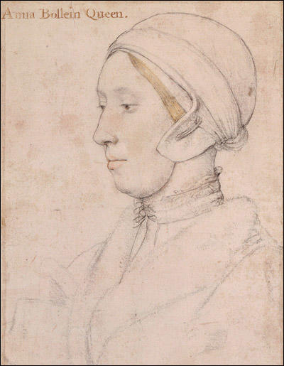

(Source 11) Philippa Jones, The Other Tudors: Henry VIII's Mistresses and Bastards (2010)
Anne made an instant impact on the Court. She had glossy dark hair, was a good musician, a graceful dancer and possessed exquisite French manners. She also dressed well, which was important since Tudor ladies were expected to show off the latest fashions. She invented a hanging sleeve to hide a blemish on one hand and a high collar that hid a mark on her neck (a birthmark or mole). She was reputed to be a wit, and men seemed to find her irresistible.

(Source 12) Kelly Hart, The Mistresses of Henry VIII (2009)
Sander showed his bias by describing her as "rather tall of stature with black hair and an oval face of sallow complexion, as if troubled with jaundice. She had a projecting tooth under her upper lip, and on her right hand, six fingers. There was a large wen (tumour or wart) under her chin, and therefore to hide its ugliness, she wore a high dress covering her throat." She was handsome to look at."
This bizarre description was written by a man who was only nine when she died; there is no evidence that Anne "wore a high dress", which was not fashionable at this time. Her portraits show that she did not usually cover her neck. Often the accusations of witchcraft marred people's description of her - how else could she have made good King Henry forsake his devoted wife and the Pope?

Questions for Students
Question 1: Read the introduction and study sources 1, 6 and 10. Explain why many historians have expressed doubts about the reliability of these portraits.
Question 2: Read sources 2, 3, 4, 5, 7 and 11. Make a list of aspects of her appearance that appear in more than one source.
Question 3: Compare what Nicholas Sander (source 3) and George Wyatt (source 4) say about Anne Boleyn. Read their biographies and assess the possible reliability of their accounts.
Question 4: Study sources 1, 8 and 9. Do these sources support the views of Sander and Wyatt?

